16th Sunday in Ordinary Time  Reading I: Wisdom 12:13, 16-19  Responsorial Psalm: 86:5-6, 9-10, 15-16  Reading II: Romans 8:26-27  Gospel: Matthew 13:24-43  Readings may be found on the US Bishop’s website:  https://bible.usccb.org/bible/readings/072323.cfm | 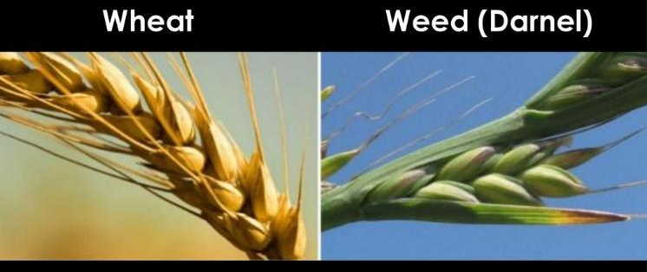

The first reading is from the Book of Wisdom. It is one of the books that were accepted by the Greek-speaking Rabbis and included in the Greek tradition of the Old Testament (Hebrew Scriptures). Later the Palestinian rabbis excluded it from the scripture list that was approved at Yamnia in the early 80s AD. Early Christians already living in the Greek-speaking. lands had begun to use the Greek translation of the scriptures and the Catholic and Orthodox churches have recognized it as part of Scripture from the first century.

Wisdom is presented in two ways. First, Wisdom is the perfection of knowledge and is a gift from God. It is manifest in the actions that one takes. Secondly, Wisdom is with God from all eternity. Wisdom was with God during creation. Christians have linked the figure of Wisdom with the Holy Spirit.

Today’s selection highlights that though God has all power, God acts out of mercy and allows us to repent. God does not have an ego to protect or a reputation that needs to be defended. God’s actions are to be instructions for us. Being generous and forgiving is a clear sign that we are the children of God. God’s mercy is a development from early biblical thought that presented God much like a human who needed to exert power against those who sinned. This is a groundwork for the message of Jesus. This is connected to the parable of the wheat and weeds.

As discussed last week, parables take a familiar situation and use it to express a new insight, that can be amazing, for the hearers. While our attention is drawn to the wheat and weeds, behind the story s the cultural norms of honor and shame. For someone to plant weeds in another’s field is an attempt to shame the landowner.

The landowner’s confidence that there will be enough water and nutrients for both crops rather than yielding to fear is one message from the parable. Trusting in goodness, in God’s providence, is more powerful than succumbing to fear. The enemy is shamed in the end when the landowner ends up with more resources than just the wheat crop would have provided. The whole practice of revenge is challenged for more can be gained by not retaliating.

The parable makes two additional points. One must be careful in making judgments of others. God is still at work in all of our lives. God can do great things if one is patient. Look at St. Paul who began by arresting Christians to bring them to trial. Paul encountered Jesus and became a great evangelist to the Greek-speaking world. Secondly, the church will always be a mixture of sinners and those moving toward sainthood. The church cannot be the gathering of the perfect. If it were, none of us would be invited. We are called to be patient with one another while God works within each of us and helps each other grow rather than criticize each other. We are all called to wait for God’s judgment. While we can name behaviors that are wrong, only God can judge the person. Discernment is the gift that helps one recognize the origin of one’s desires and the ultimate value of each.

The two other simile parables offer important perspectives. Both yeast and the mustard seed are small but can have a significant impact. The spread of the Gospel is similar. The words of Jesus can seem insignificant but when taken to heart, they have a profound impact upon a person’s life. Small steps, like taking time to pray, read the scriptures, or being attentive to one’s spouse, do not make a huge difference in one day but establishing them as a pattern can lead to profound change.

The passage from the letter to the Romans offers insight into prayer in difficult and challenging situations. In times of pain, confusion, or calamity, one may not be able to focus.
The pain can be so great, the hurt either physical or emotional so overwhelming, that there are no words available. The Spirit presents before God one’s true need with wordless cries for God’s help. Tears of pain or grief, moans of exhaustion, or stomping of one’s foot can be our expression of need before God. The Spirit helps us in our prayer and intercedes for us when we do not have words. One is never without an opportunity to call for God’s help.

Themes:
Good and evil Patience
Reign of God Intercession of the Holy Spirit

Reflection Questions
Have you encountered wheat and weeds in your own life? What helped you be aware of the differences?

What signs of imperfection in the Christian community stand out most clearly for you?

What small things have shown a great impact on your life?

Can you recall a time when having patience produced an amazing result?

Can you think of a situation in which you could not pray or someone that you knew was incapable of praying? How might the Spirit have been at work in that situation?

Prayer Suggestions
For the church: that we may allow the good seed of the Gospel to take root within us and bring forth a harvest of virtue and manifestations of the reign of God
For patience: that we may not judge one another but rather be open to the work that God is doing within each of us that will be revealed in God’s time
For a deepening of prayer: that we may offer our discontent, pain, and yearnings to God honestly and allow the Spirit to intercede for us
For Wisdom: that we may recognize the small ways God is at work in our lives so that we may cooperate with God who accomplishes great things

For the gift of humility: that we may recognize our strengths, abilities, and opportunities as gifts from God and be open to God’s invitations to serve each day

© Joseph Milner, 2023

